This report describes the collection/acquisition of aerial lidar return for the 2011 State of Kansas aerial lidar survey project. The project area covered approximately 11900 square miles in central Kansas, including all of Lyon, Morris, Chase, Dickinson, Marion, Harvey, Ottawa, Saline, McPherson, Jewell, Mitchell, Lincoln, Ellsworth, Rice, and Barton Counties, Dodge City in Ford County, and the US Fish and Wildlife Quivira Wildlife Preserve in Stafford County and Barton County to the south.

The lidar capture/flyover was performed in December 2011 and January and February of 2012. The capture was conducted from a twin-engine Piper Navajo Chieftain aircraft using a Leica ALS60 200 kHz aerial lidar system (Sensor ID No. 6133) with multiple air pulse (MPiA) capability and an integrated Leica IPAS20 airborne GPS/IMU system with a Honeywell MicroIRS inertial measuring unit. The operational settings and capture parameters used for the lidar survey were as follows:

Flying altitude 8750’ AMSL
Aircraft ground speed 160 knots
Field of View (FOV) 40 degrees
Maximum scan rate 59.4 Hz
Scan rate (SR) setting 36.3 Hz
Laser pulse rate 100.7 kHz
Multi Air Pulse (MPiA) enabled
Laser power 100%
Swath width 6560’
Sidelap/flight line spacing 25% / 5300’
Returns/pulse 4 w/last return
Average point density 0.7 pts/sq. meter
Average point spacing 1.18m/3.87’

The lidar flyover covered the entire project area and a 100m buffer. Kucera’s flight plan consisted of a total of 296 individual flight lines and 14540 flight line miles. For flyover/acquisition performance purposes the flight plan was divided into six flight blocks and the separate Dodge City area. Within each flight block the flight lines were oriented in a north-south or east-west direction for efficiency of block coverage. The flight line length was limited to approximately 60 miles or 20 minutes of on-line time to avoid excessive IMU drift.
The lidar capture was generally accomplished in 4 – 6 hour flight sessions/shifts, with multiple sessions being flown on each flight day when possible. In total, there were 34 lidar missions. Missions 01-32 completed the original project data capture. Missions 33 and 34 were necessary for reflights due to a small sensor issue found in Mission 03 and a cloud in Mission 01. Additionally, a gap out occurred between lines in Mission 09 and was reflown in Mission 21. The flying was accomplished when skies were clear or clouds were above the flying altitude of 8750’. Flying was not performed when there was significant amounts of snow on the ground or when cross-winds to the flight produced a wind correction angle (WCA) of greater than 10 degrees to prevent excessive crab/deviation in the flight direction.

For processing of the airborne GPS observation data Kucera primarily used TerraPOS technology, which requires a minimum of approximately three hours of continuous AGPS recording by the lidar system. The use of TerraPOS technology was demonstrated to and approved for use by the State. Observations from Kucera-placed base stations and CORS were incorporated as a check on the TerraPOS results. No significant loss of in-flight AGPS/IMU data/satellite lock or other GPS/IMU anomalies were experienced during the flyover.

Below is a Mission Summary, correlating missions with blocks, flight dates, lines flown, and sensor. Also included are diagrams showing the county boundaries, Kucera flight block boundaries, and mission flight lines.

Flight Mission Summary
Mission | Date | Plane | Block | Lines | Sensor
Mission01 | 121310 | 35834 | B1 | 1to10 | 6133
Mission02 | 121310 | 35834 | B1 | 11to23 | 6133
Mission03 | 121310 | 35834 | B1 | 24to32 | 6133
Mission04 | 121410 | 35834 | B1,B3 | 33and34, 72to75 | 6133
Mission05 | 121410 | 35834 | B6 | 223to232 | 6133
Mission06 | 121410 | 35834 | B6 | 233to238 | 6133
Mission07 | 121410 | 35834 | B6 | 239to248 | 6133
Mission08 | 121410 | 35834 | B6 | 249to256 | 6133
Mission09 | 121410 | 35834 | B6 | 257to264 | 6133
Mission10 | 121510 | 35834 | DodgeCity, B3 | 290to296(DCall), 76and77 | 6133
Mission11 | 121510 | 35834 | B4 | 150to157 | 6133
Mission12 | 121510 | 35834 | B4 | 158to164 | 6133
Mission13 | 121510 | 35834 | B4 | 165to171 | 6133
Mission14 | 121510 | 35834 | B4 | 108to115 | 6133
Mission15 | 121610 | 35834 | B4,B5 | 172to174,175to181 | 6133
Mission16 | 121610 | 35834 | B3 | 100-106 | 6133
Mission17 | 121710 | 35834 | B4 | 144to151, 174 | 6133
Mission18 | 121710 | 35834 | B6 | 265-272 | 6133
Mission19 | 121710 | 35834 | B5 | 203-207, 212and213 | 6133
Mission20 | 010111 | 350GB | B5 | 182to194 | 6133
Mission21 | 010211 | 350GB | B6 | 273to285, RF260gap | 6133
Mission22 | 010311 | 350GB | B2 | 35to45 | 6133
Mission23 | 010311 | 350GB | B2 | 46to57 | 6133
Mission24 | 010411 | 350GB | B5 | 195to202 | 6133
Mission25 | 010411 | 350GB | B6 | 286to289 | 6133
Mission26 | 010411 | 350GB | B5 | 208to222 | 6133
Mission27 | 010411 | 350GB | B3 | L107, 90to99 | 6133
Mission28 | 010511 | 350GB | B4 | 116to129, boresight | 6133
Mission29 | 010511 | 350GB | B3 | 79to89 | 6133
Mission30 | 010611 | 350GB | B3,B2 | line78, L58to67 | 6133
Mission31 | 022211 | 350GB | B2,B3,B4 | 130-138, RF93, 68and69 | 6133
Mission32 | 022211 | 350GB | B2,B4 | 139-143, 70and71 | 6133
Mission33 | 100511 | 350GB | B1 | RF in B1, from M3 | 7121
Mission34 | 21012 | 35834 | B1 | RF for clouds | 6133

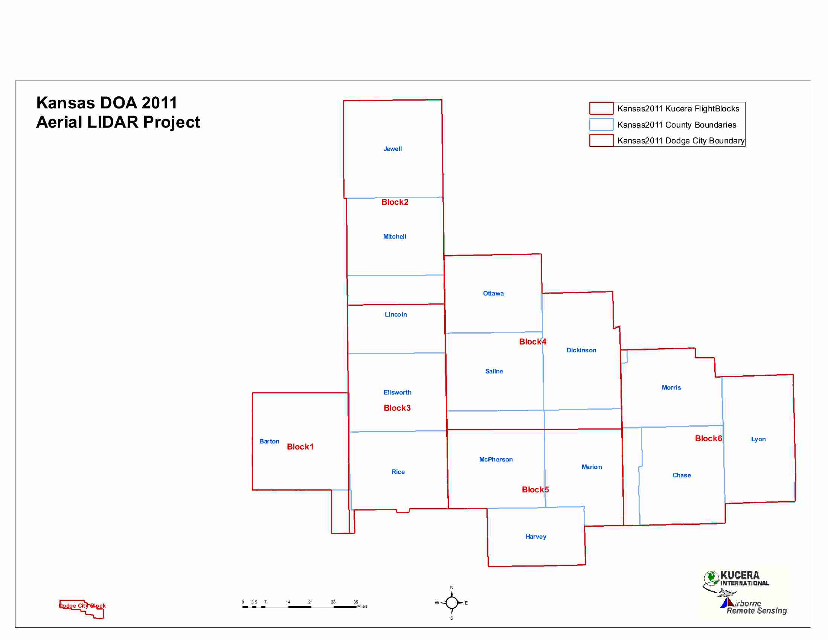

Kansas 2011 Kucera Flight Blocks
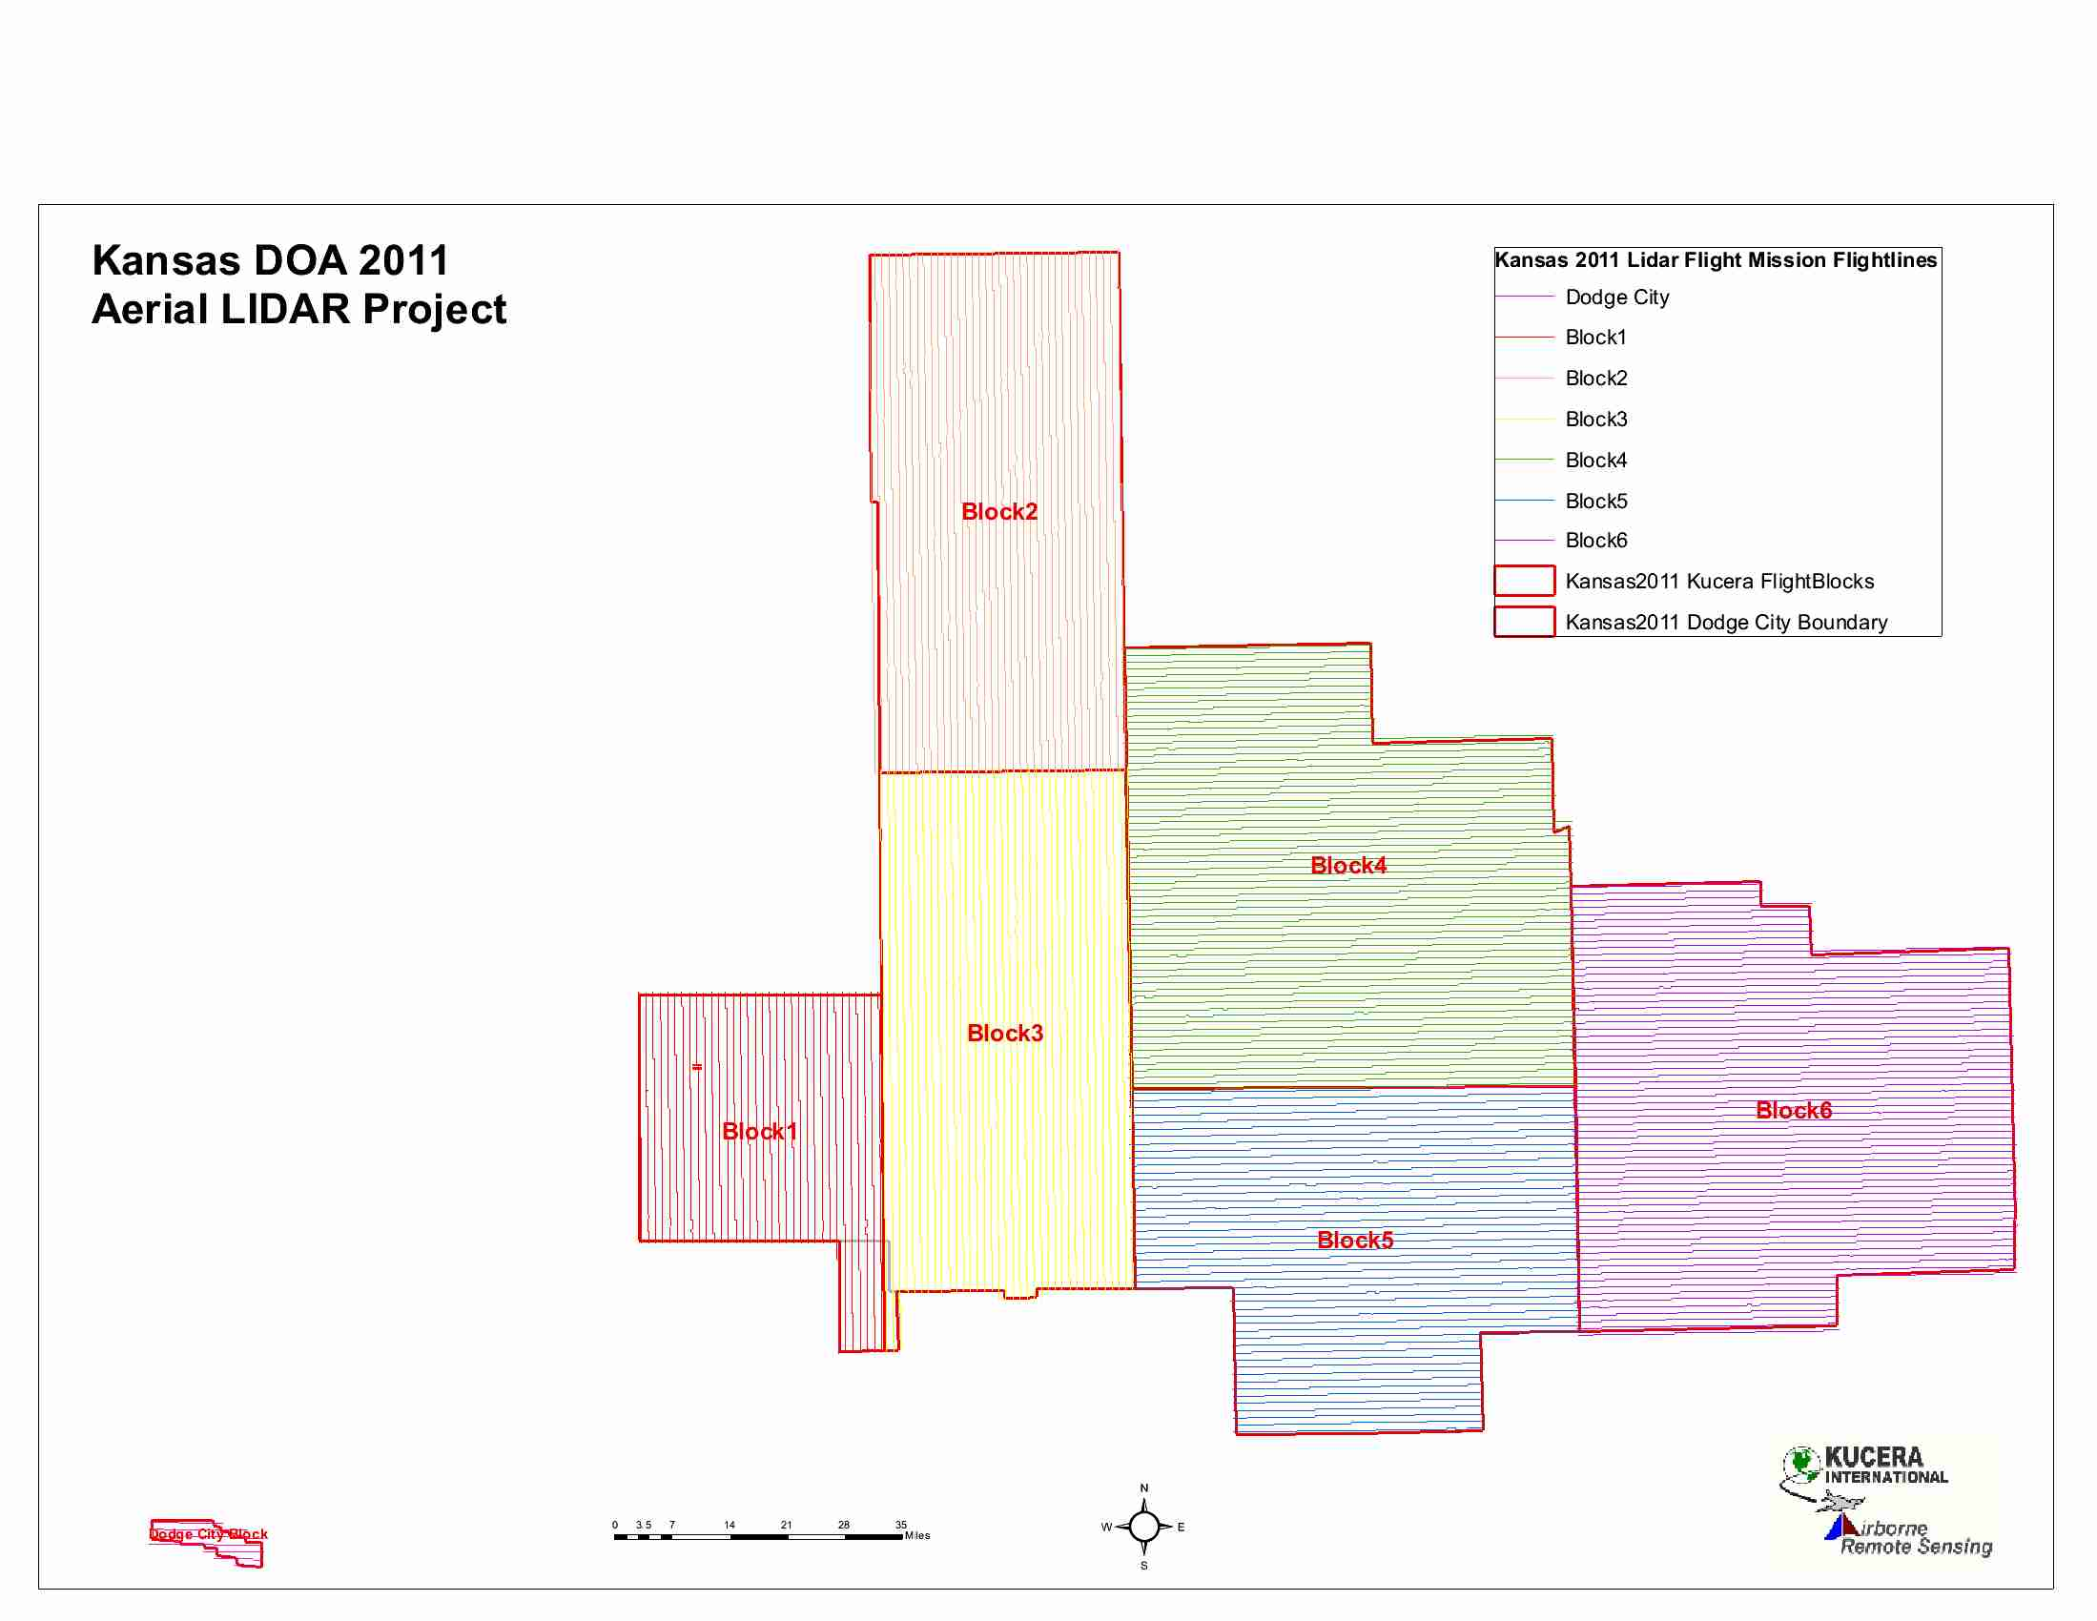
Kansas 2011 Kucera Project Flightlines

