

Mapping Missouri/Kansas Communities Workshop:

An Introduction to GIS and Community Analysis
Kansas City: June 9th and 10th, 2009*
ExecuTrain of Kansas City - 6900 College Blvd., Suite 800 Overland Park , KS, 66211
*Note: These are one-day workshops (8:30am – 4:30pm). Participants choose which day to attend. This workshop is customized for each city in which it is taught.
More Info/Registration: www.urban-research.info
- Audience: Beginners, anyone interested in mapping their community
- Registration Fee: $495 (Credit Cards, Checks, Purchase Orders Accepted) Breakfast Included

Participants will learn to use ArcGIS 9.3 to do the following:
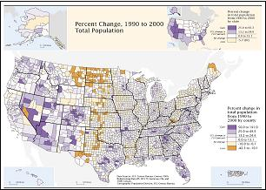
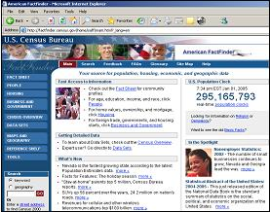

Creating thematic maps
Participants will learn to create thematic maps of their own data, and display spatial trends in information.
Address mapping (geocoding)
Participants will learn to map addresses of their clients, their projects or incidents.
Download and map Census & American Community Survey data
Participants will learn to extract and map current Census data such as poverty, race, language, population,
transportation, education and workforce characteristics.
Materials
+ Comprehensive workbook (75 pages), which includes the presentation, exercises and reference worksheets,
+ ArcGIS (ArcView 9.3) software 60-day trial CD set

